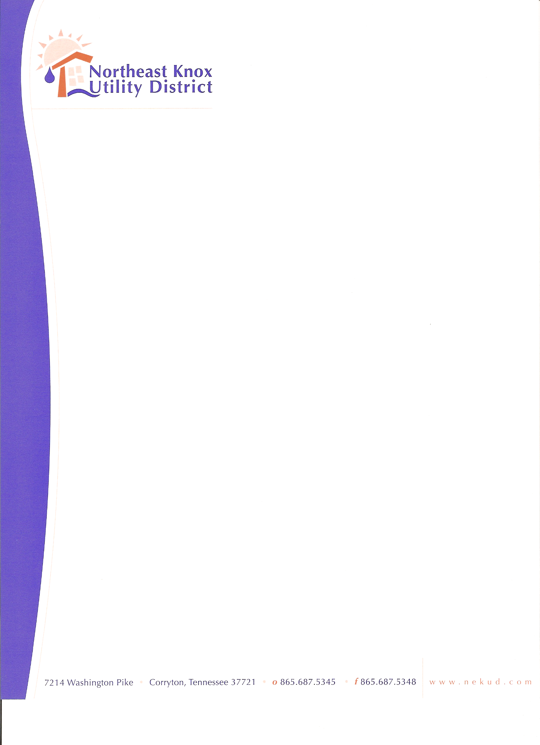
+

BOARD OF COMMISSIONERS MEETING
May 18, 2026
Agenda

- Call to Order
- Approve Minutes
- 2025-26 Audit Review by PYA
- Consider Adoption of Penny Policy
- Kyle Tague 3321 Roberts Rd.
- Financials
- Old Business
8. New Business
9. Public Comments
10. Adjourn

