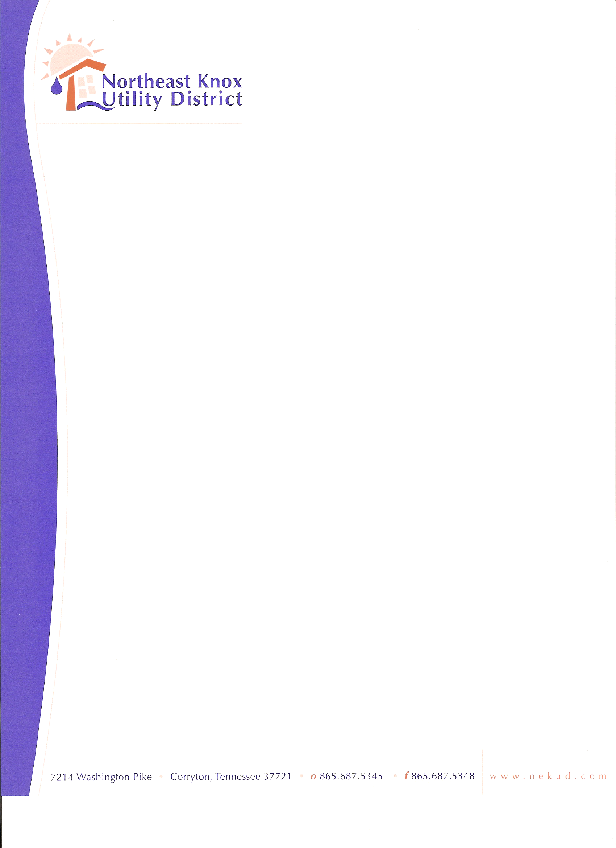
+

BOARD OF COMMISSIONERS MEETING
March 23, 2026
Agenda

- Call to Order
- Approve Minutes
- Six Month Bad Debt Write – Offs
- Hazard Communication Program Update
- Cyber Security Policy Update
- Financials
- Old Business
8. New Business
9. Public Comments
10. Adjourn

