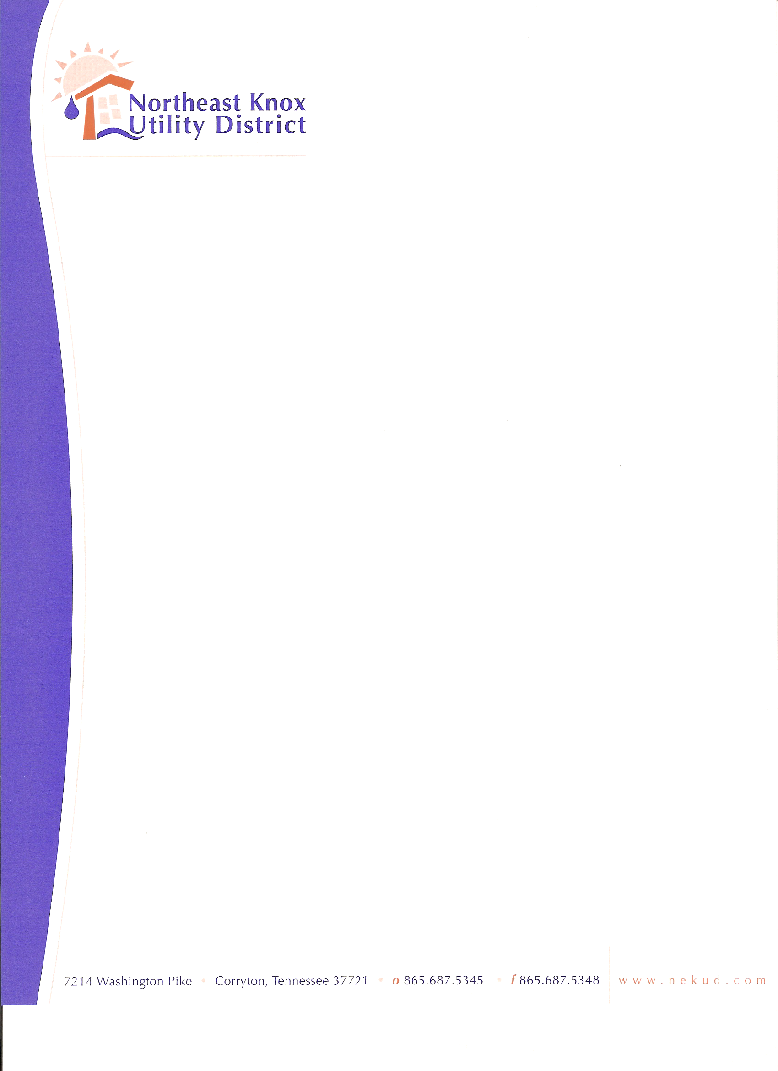
+

BOARD OF COMMISSIONERS MEETING
February 16, 2026
Agenda

- Call to Order
- Approve Minutes
- Update to Section 6.05 of Rules, Regulations, and Charges Policy.
- PYA Audit Engagement Letter
- Comptroller Budget Approval Letter
- Discuss General Liability, Umbrella, and Worker’s Comp. Insurance Renewals
- Financials
- Old Business
- New Business
- Public Comments
- Adjourn

