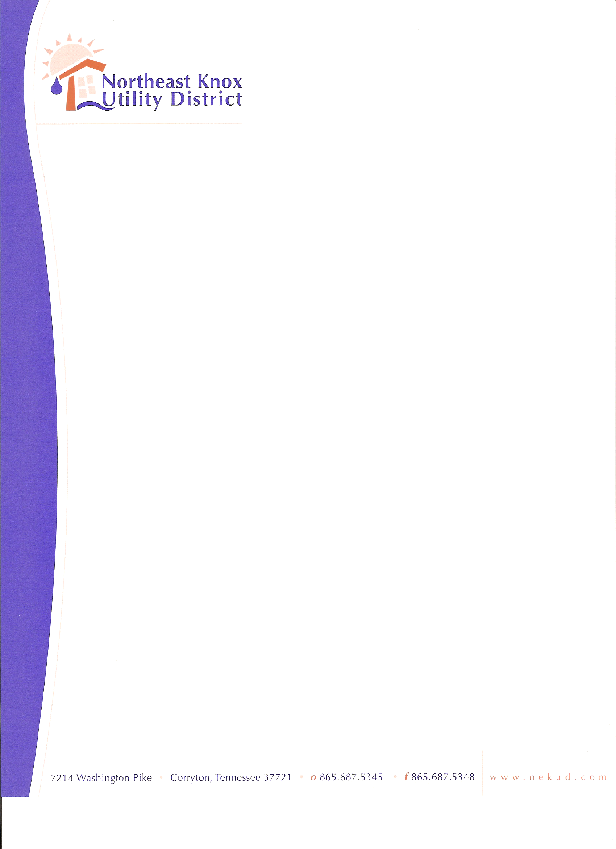
+

BOARD OF COMMISSIONERS MEETING
December 22, 2025
Agenda

- Call to Order
- Approve Minutes
- Water Plant Facility Plan - Josh Paz w/CCI
- Discuss 2026-27 FY Tap Fees and Rate Schedule
- Discuss increasing Petty Cash to $150.00
- Consider Adoption of Minimum Refund Threshold Policy
- Financials
- Old Business
- New Business
- Public Comments
- Adjourn

